**Check-in Time**

**Thurs 6 – 8pm**

**9-10pm**

**Fri 12:30 - 1pm**

**8:30-9:30pm**

**UCR**

**900 University Ave, Riverside, CA 92521**

**What we provided …**

A linen pack on the bed: 1 pillow, 1 pillow case, 2 flat sheets, 1 blanket, 2 towels, 2 hand towels, and 2 wash clothes.

Microwave and small refrigerator in each bedroom. Extra microwave, big refrigerator and sink in each living room. Small kitchen includes electric stove and refrigerator on the 1st and 3rd floor

Laundry room and lounge on the 3rd floor. Elevator in each building.

**What to bring …**

Soap, shampoo, toiletries, slippers,

water bottle, device charger…

**For kids and toddlers …**

Extra blanket, pillow, highchairs…



**Where to eat …**

**(Driving distance within 1 min)**

BZ Chinese Cuisine - Hotpot

1333 University Ave

Pokilicious - Hawaiian Poke

1400 University Ave, Ste 106,

Rockstar Shrimp - Cajun Seafood

767 W Blaine St, Ste C

Big Sky Restaurant - Dim Sum

1575 University Ave, Ste A

Ramen Okawari – Ramen

3740 Lowa Ave, Ste 104

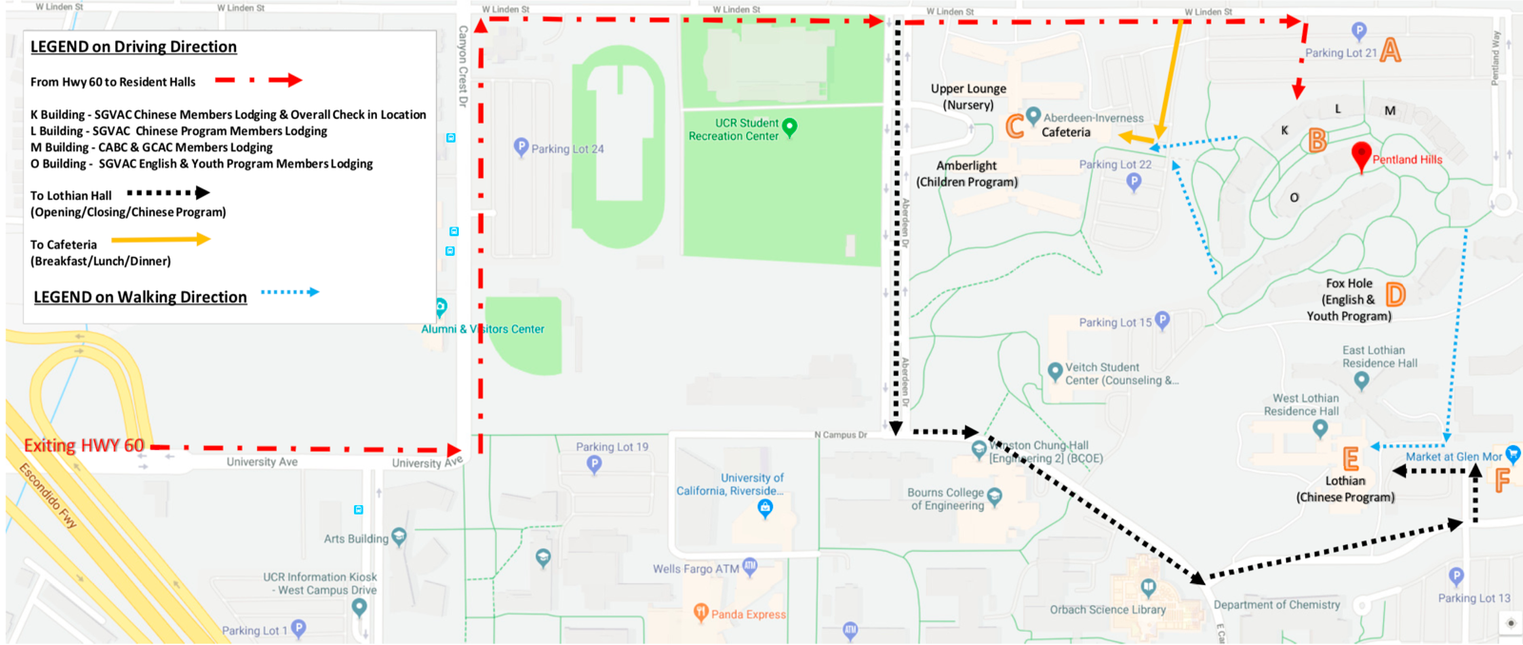

**Point A: Parking Lot 21 / Our Reserved Parking**

**Point B: Pentland Hills / Lodging**

**Point C: Aberdeen-Inverness / Nursery & Children’s Program, cafeteria.**

**Point D: Pentland Hills Fox Hole / Youth & English Program**

**Point E: Lothian / Opening & Closing Ceremony, Chinese Program**

**Point F: Grocery Store & Starbucks Thurs & Fri 6:30am – 5pm, Sat & Sun 8am-3pm**

**Important Information:**

* Parking – Participant **MUST** obtain a parking permit for the duration of the conference. You can get a parking permit at the registration table.
* **Check-in at Point B, Building K. Check-in time slots,**
* If you miss the check-in time, please meet with our staffs at the cafeteria or meeting place to get a parking permit first. Our team will assist you for check-in later.
* If you are rushing to get something to eat or want a cup of coffee, Point F offers you to-go meals with choices of sushi, sandwich, salad and pizza.
* ER - Riverside Community Hospital,

4445 Magnolia Ave, Riverside, CA 92501. (951)788-3000 (3mi)

* 24/7 Rite Aid 5225 Canyon Crest Dr. Ste 8, Riverside CA 92507 (1.2mi)

Friday 12:30 – 1pm

8:30 – 9:30pm

Thursday 6-8pm

9-10pm